1.Design Principle:
1)Mobile First
We are doing MVP on laptop right now. but eventually users will use the app on mobile devices most of the time. Therefore, the app layout and workflow design should be based on cellphone screen
2) Intuitive and low friction workflow
Sports Coaches (tennis coaches for MVP stage) are busy. They are doing 10-12 classes per day. The app enable them to record message on the fly. Therefore, need to be very easy and intuitive workflow. Two action buttons at most each screen. Low cognitive load
Visual should look calm, simple, minimal
3) Interchangeable skin:
The app is for tennis coach for MVP stage. Eventually can be for all kinds of sports activity coaches (ski, swimming… etc).
Depend on the sports activity:
- the layout, workflow and component should be the same, including spacing, button hierarchy, typography, fonts style… etc
- the “skin” can be different: colors, images, branding
4) One Handed Operation
Coach needs to be able to record their class message on the fly: outdoor, in the car, while holding a racket, carrying gears or basket… etc
5) Outdoor Readability:
high contrast color pattern. Big button. Making it easy to read under the sun
6) 60 second goal:
coach should be able to record a message and complete the whole tasks within a min
7) Warm and Encouraging Tone
The app’s function is to help coach record class review message, and communicate with students easily.
The emotional goal is for coach to build connection, empowerment to help student continue to learn through warm and encouraging message and actionable next steps
8) Bilingual:
Mandarin and English
All layout/wording need to be able to interchange once option set.
Except the Logo, App Name and subtitle (EcoCoach- Coach, Connect, Capture)
Many coach clients speak English or Mandarin

2. Key Design Element:
1)Logo: can be something like below. (not necessarily same color)
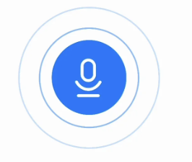
2) Color tone and background: green -tennis theme. Could be gradient from light green to dark green. .. etc with shadow applied properly
For the tennis skin: can add tennis elements in the background, such as tennis racket, tennis ball, tennis players…. But don’t be too crowded.
3) App Name: EchoCoach
Subtitle: Coach, Capture, Connect
Tagline: Speak your notes after class. EchoCoach turns them into a warm, professional message for your student
4) Button:
Similar to below screen shot. Please have some shadow. Color tone adjust as fit.
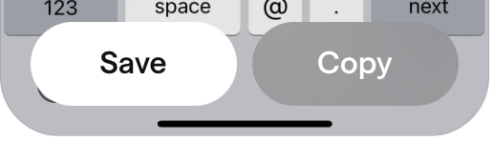

3. Pages.
1)Home Page
- similar to below screen shot: change to our app name, logo, color tone and background. Similar font and style.
- action button: instead of “Get Started”, use “ New Class Review”.
-add a popup bar: two pop up button – 1) go to log history 2) Language drop down: English or Mandarin. Font size should be similar to the tag line font
- Language Drop Down: once English or Mandarin chosen. All subsequent pages will show in English or Mandarin
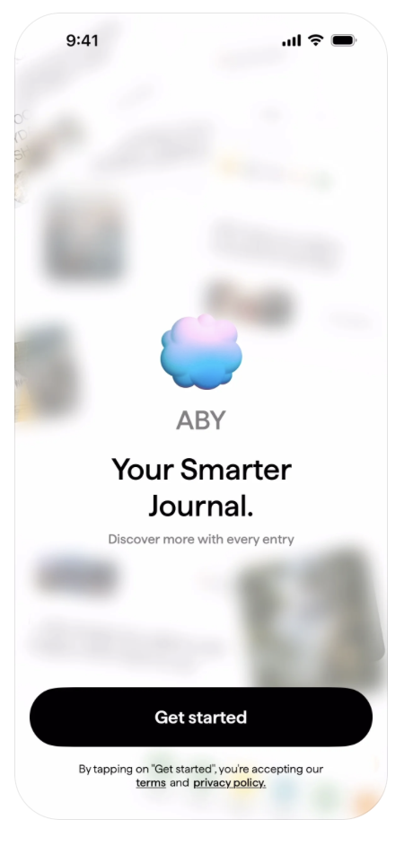
- Review Intake Pages
- There are four questions pages, all should follow same styles and design patterns
- Four questions pages student’s name, what we did in class, what was the progress and next steps
- Voice Capture pages:
i. prompt page
similar to below screen. The wave should have some motions, not static. Background color changes to our color tone. Prompt wording need to be adjusted accordingly. Similar Fonts and style
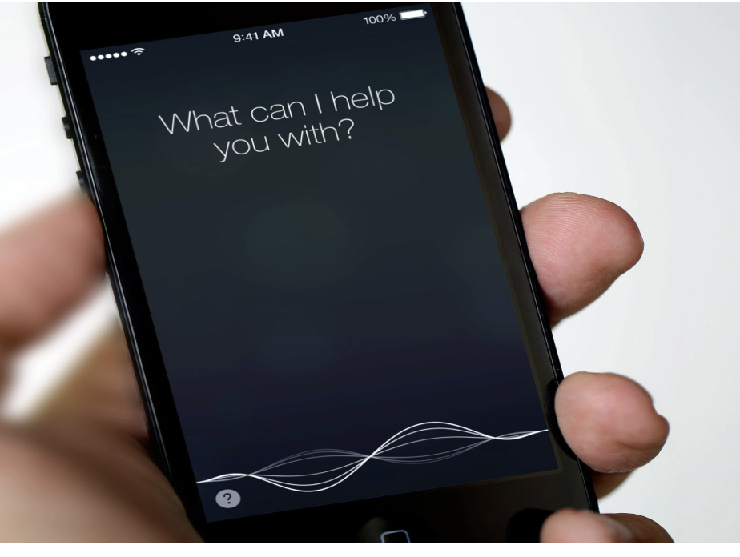
ii. when recording message
- something like below Shazam’s interface (there is motion in the circle and the audio bar while listening, not static)
- description at the bottom to indicate the app is listening. Use similar font and style. Change the wording accordingly
- background color can be changed to our color tone instead
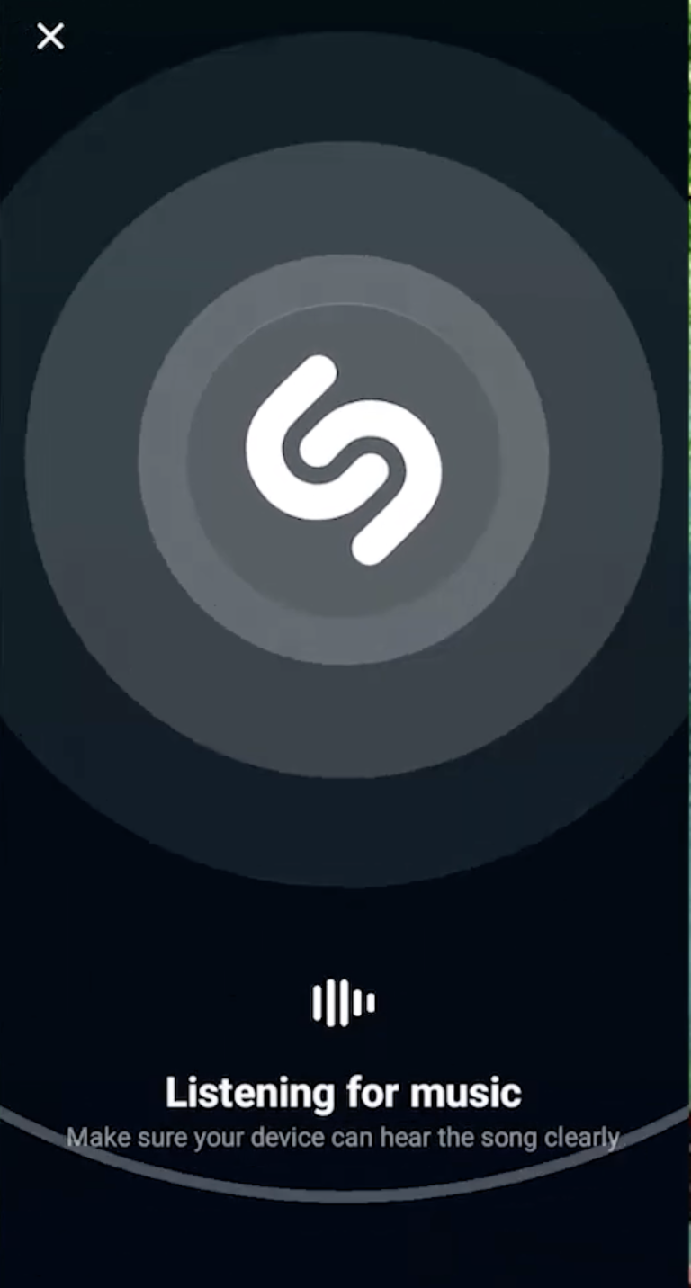
iii. Recording approval Page:

Similar fonts, style and topography for the headlines and text main body.
Nice to have some pictures band same location as the screenshot. But one wider picture instead of three small pictures.
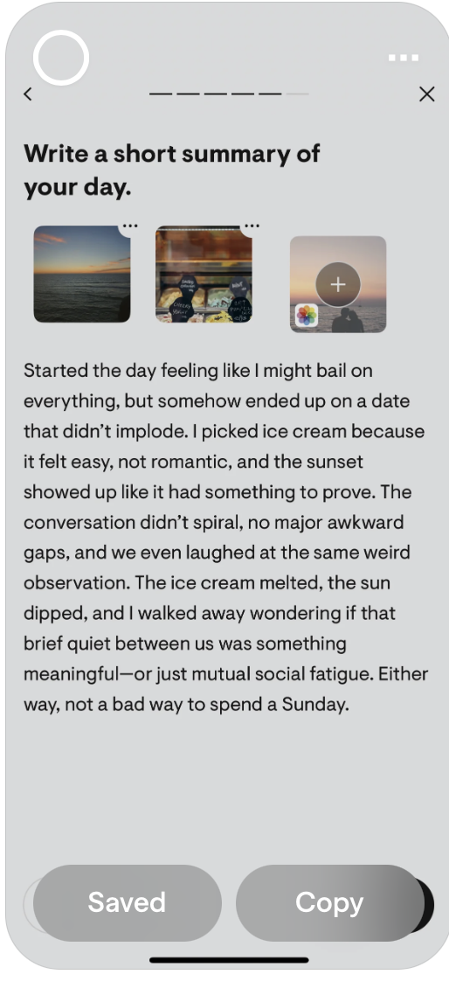
- Message Generation Page:

Smiliar style as recording approval page

